Week 1 Report: Superstore Sales Data Import, Power Query & Data Cleaning

Introduction
Building on last week's work of importing and performing an initial cleanup of the Superstore dataset, this week focused on going deeper into the Power Query Editor to apply more advanced transformations. Rather than just fixing data types and removing inconsistencies, the goal this time was to reshape the data so it carries more analytical value — standardising text fields, generating custom and conditional columns, breaking dates down into finer attributes, and making sure every column's type respects the correct regional format before the model is loaded.

Step 1: Reviewing the Existing Query and Applied Steps
Before making new changes, I reopened the query in the Power Query Editor and reviewed the Applied Steps pane under Query Settings. This let me trace exactly what had already been done to the data — from the initial Source and Promoted Headers steps through the type changes applied in the previous session — and confirm that each transformation had executed without errors before adding anything new on top.
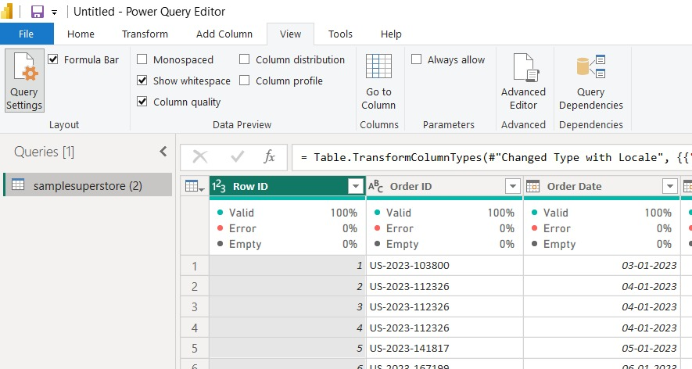
Figure 1: Query Settings pane showing the Applied Steps history for the Superstore query.

Step 2: Standardising Text with Case Transformations
Several text columns, including Product Name and Category, had inconsistent capitalisation that would make grouping and visual filtering unreliable. Using the right-click Transform menu on a column, I applied the UPPERCASE option so that every value followed the same casing convention. The same menu also exposes lowercase, Capitalize Each Word, Trim, Clean, and even JSON/XML parsing options, which are useful for cleaning whitespace or working with nested data in other columns.
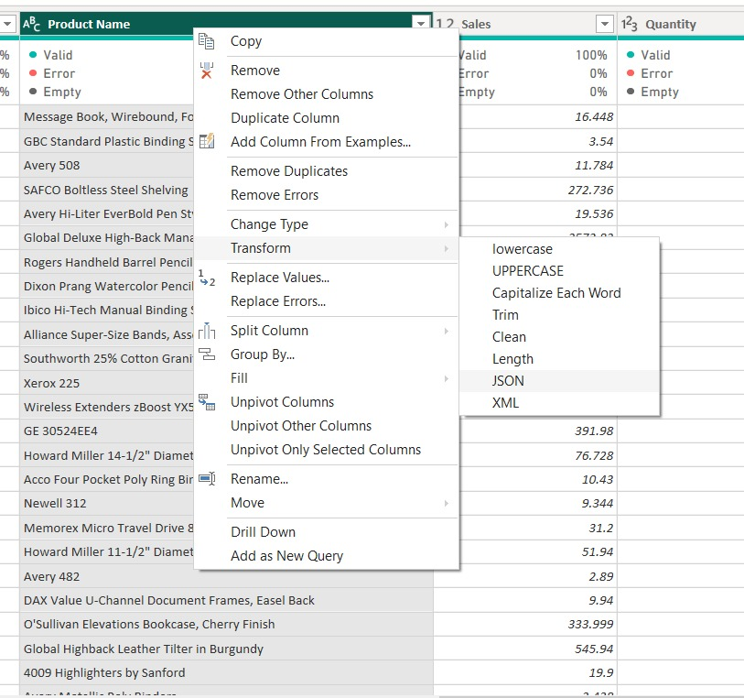
Figure 2: Right-click Transform menu used to apply an UPPERCASE conversion to the Product Name column.
After applying the transformation, the Product Name and Category fields — along with Ship Mode, Customer Name, Segment, and other text columns — were checked in the preview to confirm the change had taken effect consistently across every row, with no errors or empty values introduced in the process.
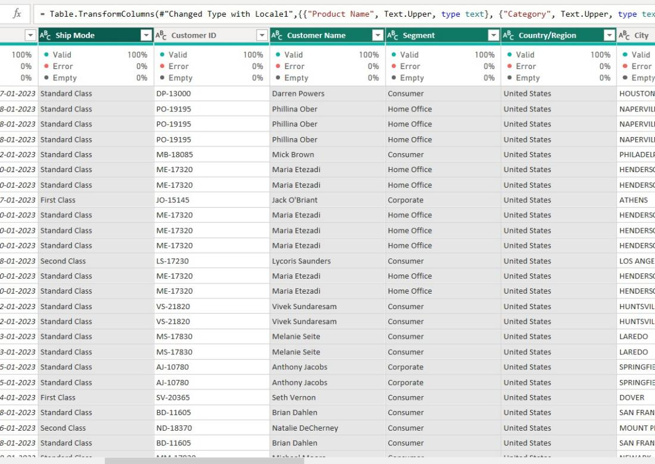
Figure 3: Preview confirming the standardised (uppercase) text values across the relevant columns.

Step 3: Building a Custom Column with a Power Query Formula
To extract the day component from the Order Date column in a way I could control directly, I used Add Column → Custom Column and wrote a short M formula, Date.Day([Order Date]), setting the output type to a whole number. This is a good example of combining the Power Query UI with manual M code — the interface generates the column shell, but the formula itself defines exactly how the value is calculated from the source field.
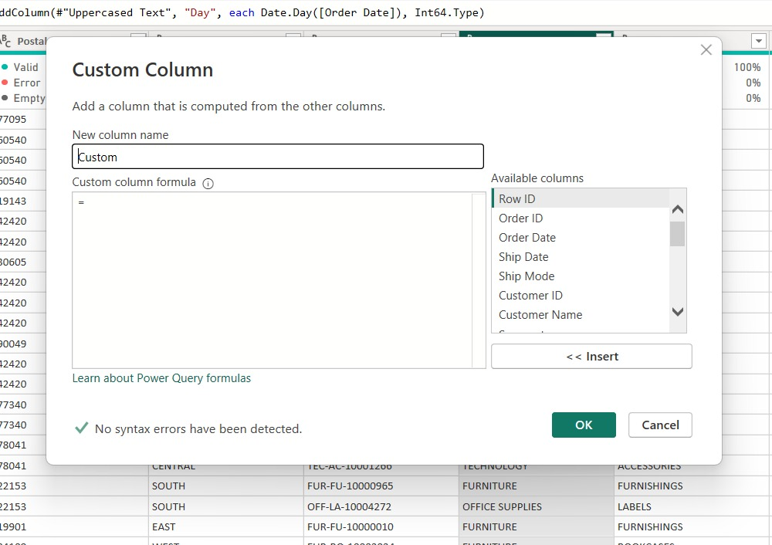
Figure 4: Custom Column dialog creating a 'Day' column using the Date.Day() function.

Step 4: Creating a Conditional Column
I also explored the Add Conditional Column feature, which builds simple if-then-else logic without needing to write M code by hand. It lets you pick a source column, an operator, and a comparison value, then define an output for each condition and a fallback Else value — useful for tasks like flagging order sizes, categorising regions, or labelling shipping delays based on existing columns.
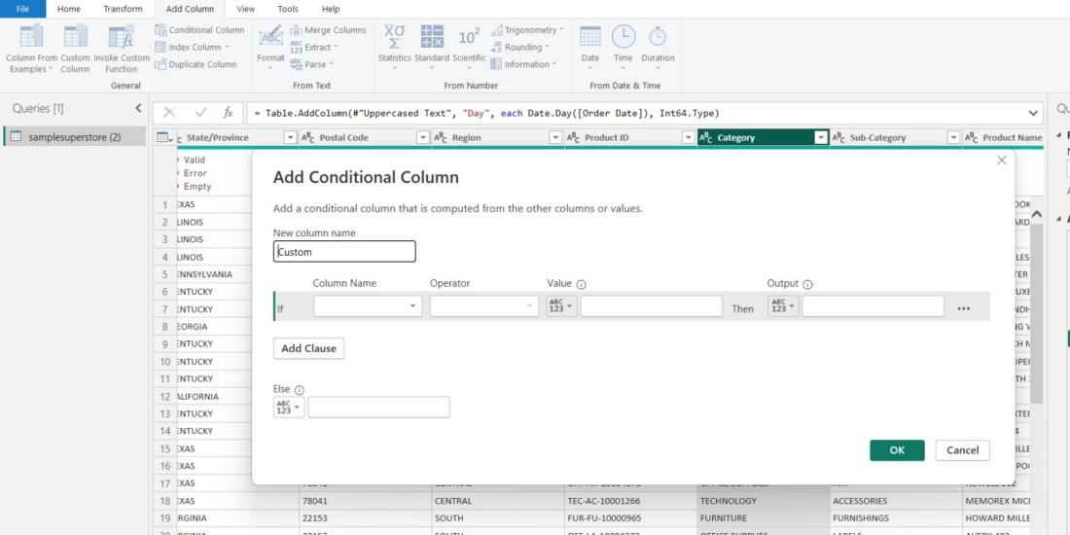
Figure 5: Add Conditional Column dialog for defining rule-based logic on the dataset.

Step 5: Extracting Additional Date Attributes
Continuing the time-based breakdown from last week, I used the Add Column → Date → Day submenu to see the full range of day-level attributes Power Query can generate automatically, including Day, Day of Week, Day of Year, Subtract Days, Combine Date and Time, and Earliest/Latest. This is in addition to the Year, Quarter, and Month options explored previously, giving a much richer set of temporal fields to work with in later analysis.
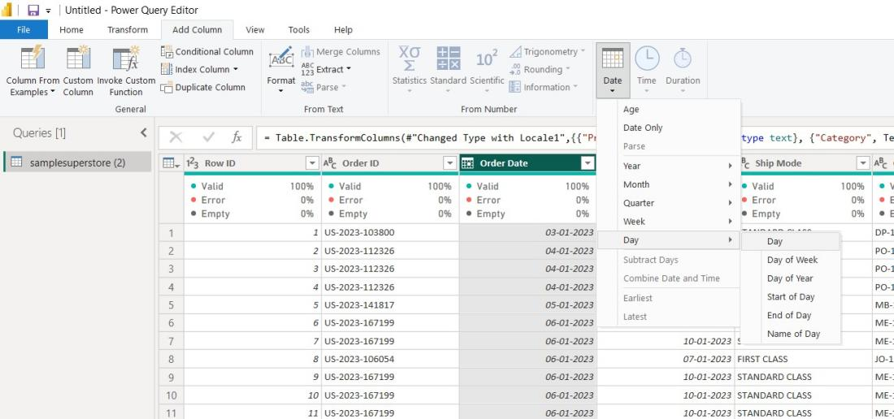
Figure 6: Add Column ribbon showing the Date → Day submenu with additional day-level extraction options.

Step 6: Applying Locale-Specific Date Types
While reviewing the Ship Date column, I noticed the default type conversion could misread the date format depending on regional settings. To avoid this, I used Change Type → Using Locale on the column and explicitly set it to Date with the en-US locale, which ensures the day/month ordering is interpreted correctly regardless of the system's default locale.
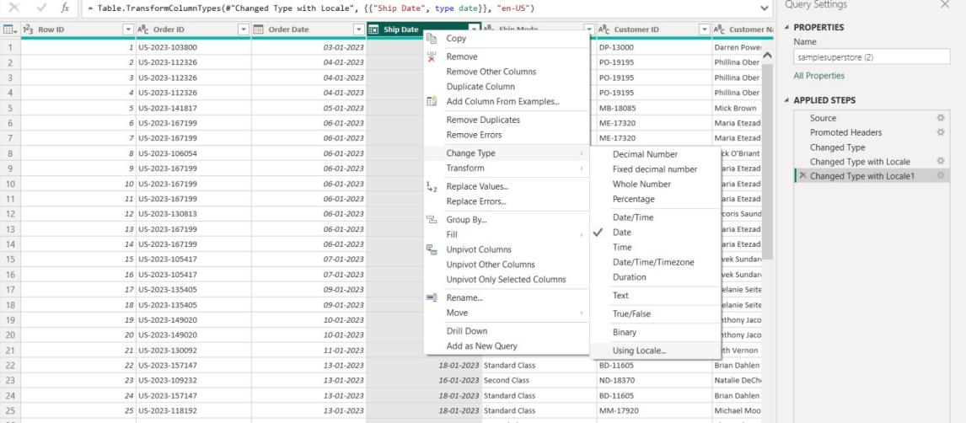
Figure 7: Using the 'Using Locale' option to correctly set the Ship Date column's type and regional format.

Step 7: Applying the Changes
With the text standardisation, custom column, conditional column, and locale-corrected date types all in place, I used Close & Apply to load the updated query back into the Power BI data model, replacing the earlier version of the table.
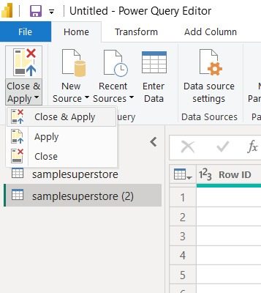
Figure 8: Close & Apply menu used to load the transformed query into the data model.

Deliverables
- An updated Superstore query with standardised (uppercase) text fields.
- A custom column generated using an M formula, plus a conditional column built with the Add Conditional Column tool.
- Additional date-based columns extracted using the Date → Day options.
- The Ship Date column correctly typed using locale-aware conversion.
- Screenshots documenting each transformation step in the Power Query Editor.

Conclusion
This week's work moved beyond basic cleaning into more deliberate data shaping — using custom formulas, conditional logic, and locale-aware type conversion to make the Superstore dataset both more consistent and more analytically useful. Understanding how the Power Query UI and its underlying M code work together, rather than treating them as separate tools, made it much easier to control exactly how each column was transformed. With cleaner text fields, richer date attributes, and correctly typed dates now in place, the dataset is in a stronger position for building accurate visuals and deeper analysis in the coming weeks.

